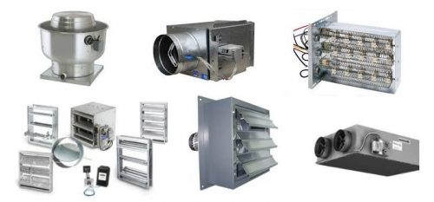

|  |  |  |
| --- | --- | --- |
| **LIST OF HVAC EQUIPMENTS** | | |
| **SR.NO** | **DESCRIPTION** | **TAG** |
| 1 | Window Unit | WU |
| 2 | Mini Split Unit | MSU |
| 3 | Floor Standing Unit | FSU |
| 4 | Air Handling Unit | AHU - DX |
| 5 | Fan Coil Unit | FCU - DX |
| 6 | Chilled Water Air Handling Unit | AHU - CW |
| 7 | Chilled Water Fan Coil Unit | FCU - CW |
| 8 | Air Cooled Condensing Unit | ACCU |
| 9 | Package Air Condition Unit | PACU |
| 10 | Window Unit | WU |
| 11 | Mini Split Unit | MSU |
| 12 | Floor Standing Unit | FSU |
| 13 | Computer Room Air Condition Unit | CRAC |
| 14 | Air Cooled Chiller | ACH |
| 15 | Water Cooled Chiller | WCH |
| 16 | Cooling Tower | CT |
| 17 | Exhaust Fan | EF |
| 18 | Electric Duct Heater | EDH |
| 19 | Air Separator | AS |
| 20 | Volume Damper | VD |
| 21 | Motorized Damper | MD |
| 22 | Fire Damper | FD |
| 23 | Smoke Damper | SD |
| 24 | Fire Smoke Damper | FSD |
| 25 | Blast Damper | BD |
| 26 | Back Draft Damper | BDD |
| 27 | Supply Air Diffuser | SAD |
| 28 | Steam Humidifier | HU |
| 29 | Return Air Diffuser | RAD |
| 30 | Supply Air Grill | SAG |
| 31 | Return Air Grill | RAG |
| 32 | Galvanized Duct | GD |
| 33 | Linear Slot Diffuser | LSD |
| 34 | Jet Diffuser | JD |
| 35 | Chilled Water Pipe | CWP |
| 36 | Refrigerant Pipe | RP |
| 37 | Chilled Water Valves | GV |
| 38 | Chilled Water Pump | CWP |
| 39 | Expansion Valve | EV |
| 40 | Automatic Air Vent | AAV |
| 41 | Access Door | AD |
| 42 | Air Transfer Duct | ATD |
| 43 | Thermostat | T |
| 44 | Variable Air Volume | VAV |
| 45 | Variable Air Volume | VAV |
| 46 | Sand Trap Louver | STL |